The following resources are associated: The dataset *’Cholesterol.csv’ and ‘Getting started in Jamovi’*

Paired t-test and Wilcoxon signed rank in Jamovi

Dependent: Continuous (scale)

Independent: Binary (before/after or condition)

Common Applications: The paired t-test is used when two measurements of the same variable are collected for each individual. For example, assessing whether there is a change in weight before and after a diet or comparing taste scores for two products when each individual tastes both.

The Wilcoxon signed rank test is used when the paired differences are very skewed or the dependent variable is ordinal. Both tests are covered within this resource.

Research question: Does using Clora margarine for four weeks change cholesterol?

**Data:** Participants used Clora margarine for 8 weeks. Their cholesterol (in mmol/L) was measured

before the special diet, after 4 weeks and after 8 weeks. Open the csv file ‘*Cholesterol.csv’* in Jamovi.

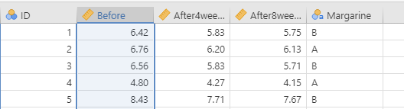

There is one row per person with their cholesterol levels at the three time points in different columns e.g. The ‘After4weeks’ column contains the cholesterol measurements after 4 weeks on the diet.

Note: Although there are three time points which can all be analysed together using Repeated Measures ANOVA, only the comparison of cholesterol before using the margarine and after 4 weeks is tested here.

## Summary Statistics and checking normality

Since cholesterol level is continuous (scale) data, it can be summarised by producing the average (mean) and standard deviation. When comparing paired measurement data, either compare the means at the two time points or calculate the paired differences and summarise this with one mean. As the paired differences need to be approximately normally distributed for the paired t-test to be reliable, a new variable of the paired differences needs to be calculated. This can be done by selecting the “Compute” option in Jamovi.



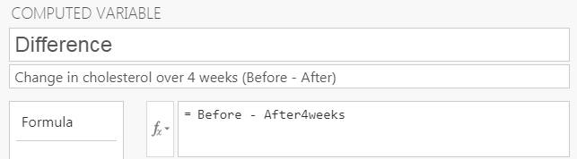Give the new variable a name and label, then type the variable names and calculation you wish to use in the function box using *=Before – After4weeks*. The new variable will be added to the dataset.

In order to calculate the mean and the standard deviation for the measurements of cholesterol before the diet, after 4 weeks on the diet and the paired differences, go into “Exploration” and then “Descriptives”. Move the before and after variables and the difference into the “Variables”. The statistics will automatically appear on the right hand side.

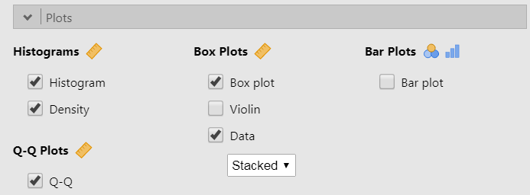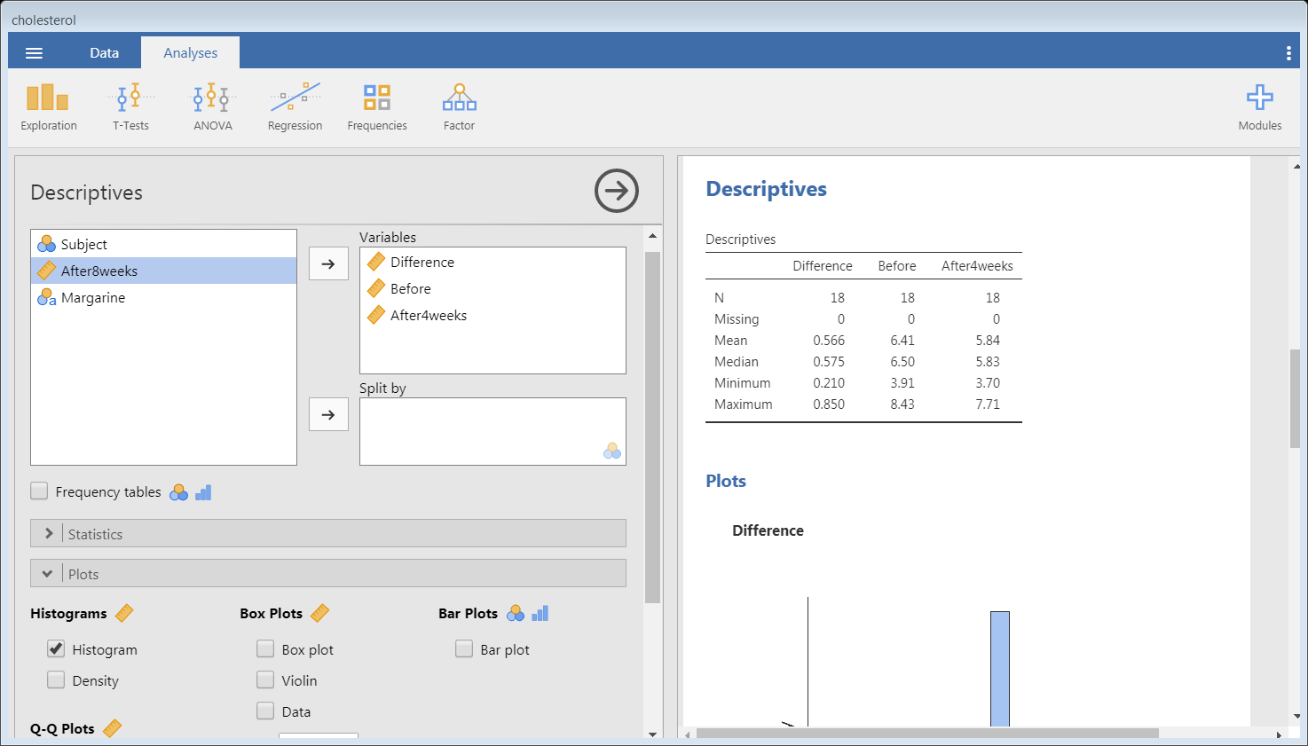

Participants had an average starting cholesterol measurement of 6.41 mmol/L and reduce their cholesterol by an average of 0.566 mmol/L during the first four weeks of using the new margarine. The minimum value is above 0 indicating that all participants reduced their cholesterol in the first four weeks.

## Charts for paired t-test

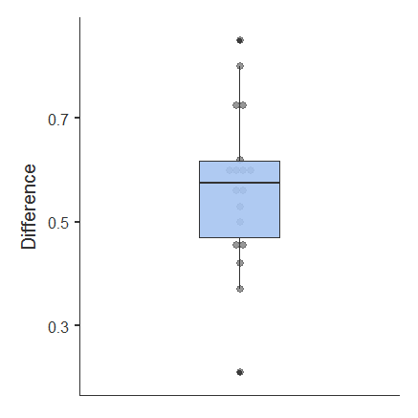You can select a few different charts in the Plots section of the Descriptive menu.

When writing a report, a box-plot is a useful way of summarising paired differences. Jamovi has the option of adding the actual data points to the boxplot by selecting the “Data” option as well as the “Box-plot” option. Each difference is represented by a dot on the chart so this may not be appropriate for large sample sizes.

The box-plot of the differences is a better chart for summarising the data in a report than a histogram. The box contains the middle 50% of the paired differences (interquartile range) and the line in the centre is the median difference. The dots help look at the individual values including the minimum and maximum.

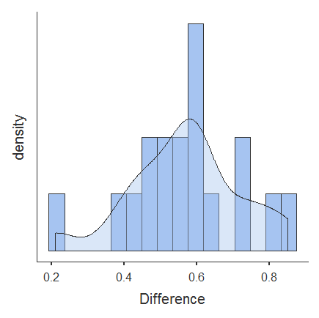Histograms (with density) and QQ plots are charts to assess whether or not the paired differences are approximately normally distributed.

The histogram of the paired differences suggests the data are approximately normally distributed and therfore the t-test is valid. If the data are really skewed, the paired t-test is not reliable and the Wilcoxon signed rank test should be used instead (see end of sheet for details).

Data has to be very skewed to cause problems with t-tests.

## Conducting a paired t-test

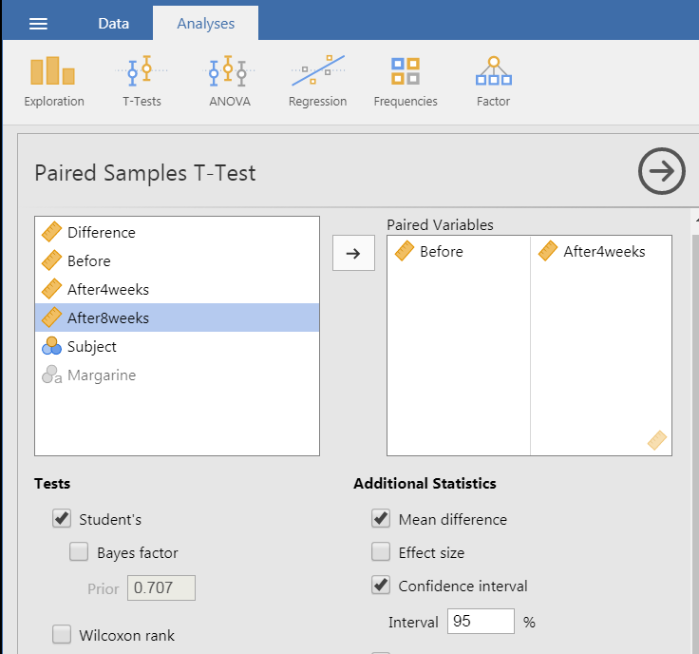

To carry out the paired t-test, go to the T-Tests menu on the Analyses tab.

Move the before and after variables to the right hand side. The t-test is carried out automatically but it is also useful to request the “Mean difference” and it’s “Confidence interval”.

You can request descriptive statistics and plots through the menu but these are for the individual before and after variables rather than the paired differences.

If your data are very skewed, you can request the “Wilcoxon rank” test through this menu.

## Interpreting the output

The paired t-test calculates a test statistic from the paired differences. If there was no change in cholesterol between the two time points, the mean difference of the values would be close to 0. The output below shows that the mean difference for this sample is 0.566 and the test assesses whether this difference is big enough to conclude that the margarine helps change cholesterol in the general population.

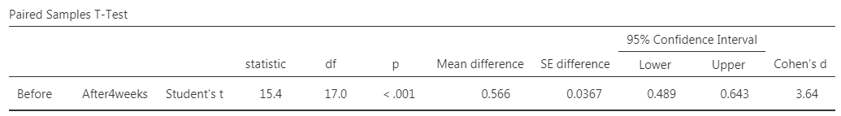

The test statistic is given as t=-15.439 in the ‘statistic’ column and the p-value of p < 0.001 is contained in the ‘p’ column. We generally compare the p-value to the significance level of 0.05 and any p-value smaller than that indicates a significant change in cholesterol.

In this data set, using Clora for 4 weeks, improved cholesterol levels, on average, by 0.566 mmol/L. Of course, if we were to take other samples, we could get a 'mean paired difference in cholesterol levels’ which is different from 0.566. This is why it is important to look at the 95% Confidence Interval (95%*CI*) which gives a range of values within which the true population mean change lies.

Reporting: A paired t-test was carried out to see if using Clora margarine for 4 weeks changed cholesterol levels. There was significant evidence (*t(17)* = *−*15*.*439*, p* < 0.001) of a change in cholesterol levels. On average, participants reduced their cholesterol by 0.566 mmol/L [95% CI: 0.49, 0.64].

Meaningful differences

Sample size impacts on statistical significance so the bigger the sample, the more likely a significant result is and large actual differences for small sample sizes may not be significant. Use the mean and CI of the difference to assess whether the observed difference is practically important, not just statistically significant.

Another method for reporting the magnitude of a difference is to calculate the mean change as a percentage of the mean starting cholesterol:



The average person lost 8.8% of their starting cholesterol which seems practically important as well as statistically significant.

## Carrying out a Wilcoxon signed rank test

If your initial histogram of the differences is very skewed or you have ordinal data, it is more appropriate to use the Wilcoxon signed rank test which is available within the paired t-test menu.

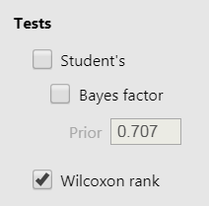Follow the same steps as the paired t-test above but select the “Wilcoxon rank” option instead of the “Student’s” t-test option. The paired difference is still being tested but the test is based on ranks (e.g. ranking the lowest change to the highest) rather than the actual differences like the t-test. The test is not necessary in this situation but we will use this example to demonstrate the reporting of the test.

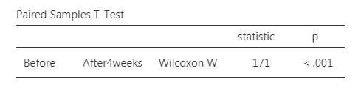

**Reporting when differences are very skewed:** A histogram of the paired differences was very skewed so a Wilcoxon Signed Rank test was carried out to test for a change in cholesterol after 4 weeks using Clora. There is significant evidence (p < 0.001) to suggest a change in cholesterol.

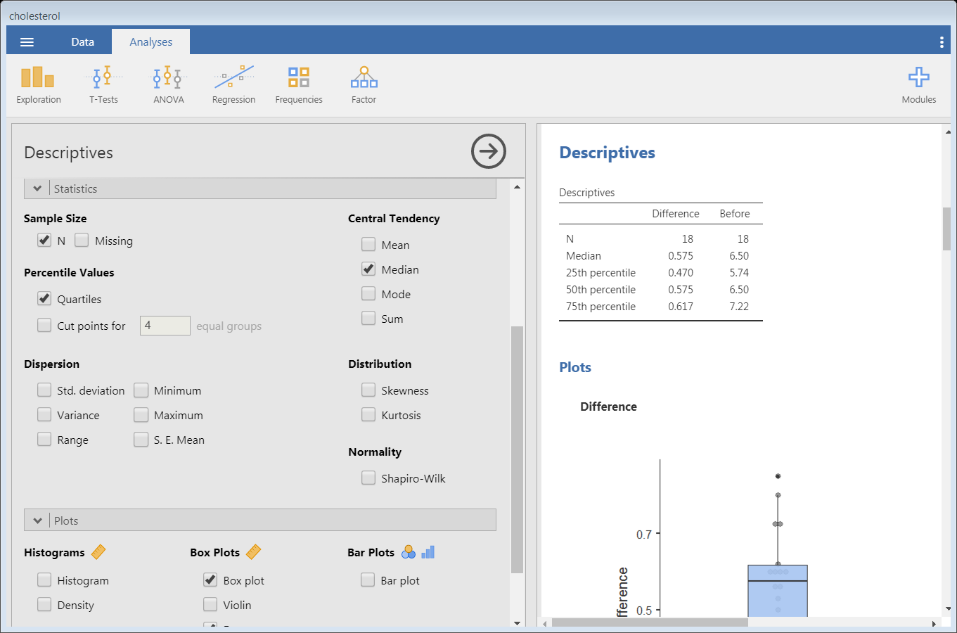**Summary statistics/chart:** For skewed data, the median, quartiles and a box-plot should be used to summarise the difference. All of these can be obtained from the **Descriptives** menu as below.

The median cholesterol reduction was 0.575 mmol/L and the middle 50% of participants reduced their cholesterol by 0.47 to 0.62 mmol/L.